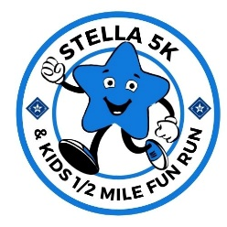
THE 2nd ANNUAL STELLA 5K and KIDS ½ MILE FUN RUN
To support the Camp Stella Maris Campership Fund
Sponsorship Form
Event Date: April 29, 2023
Please return your completed form to Camp Stella Maris by April 11, 2023, to be listed on promotional material.

I represent/am a: Business Individual
Company/Sponsor Name: ____________________________________________________________________
Contact Name: ______________________________Contact Email: __________________________________
Contact Phone: _____________________ Address: _______________________________________________

Sponsor Levels Benefits
Bronze Sponsors ($100)

Social Media recognition, Name on runner shirts, 1 race entry.
Social Media recognition, Small logo on runner shirts, Logo/name on website, Logo on flyers, Sign at finish line, 2 race entries.
Silver Sponsors ($250)

Platinum Sponsors ($1,000)
Gold Sponsors ($500)

Social Media recognition, Medium logo on runner shirts, Logo/name on website, Logo on flyers, Sign at finish line, 5 race entries.
Race Sponsor ($5,000)
Finish line banner, Social Media recognition, Large logo on runner shirts, Logo on website, Logo on flyers, 15 race entries.
Social Media recognition, Large logo on runner shirts, Logo/name on website, Logo on flyers, Sign at finish line, 10 race entries.

Thank you for you support of this event.

Payment Options: Please mail this form to:
Camp Stella Maris
4395 East Lake Rd
Livonia, NY 14487
Check payable to Camp Stella Maris
Visa Master Card
Credit Card # ___________________ Exp. ______
Signature: _____________________ CVC ______
Zip Code: ______________________

