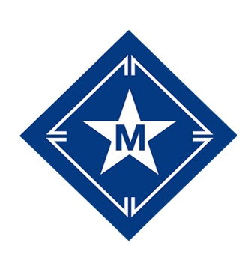

Summer Camp Payment Policy:
- A deposit of $75/camper per session is required at the time of registration.
- All registrations must be paid in full by June 1, 2024.
- Registrations with unpaid balances cannot be guaranteed after June 1, 2024.
- Final payments made by check must be postmarked by May 24, 2024.

Summer Camp Refund Policy:
- Cancellations prior to June 1, 2024, a full refund, less your deposit, will be issued.
- Cancellations on or after June 1, 2024, no refund will be issued.
- We know that schedules can change at the last minute. If something comes up on or after June 1, give our office a call and we’ll work with you to get your camper into another week if there is an open spot.* If for some reason we can’t, we’ll keep that money on your family account for up to one year.**
- In the case of an injury or serious illness that prevents your camper from attending their session we’ll work with you to get your camper into another week, if there is an open spot, and a doctor has cleared them to participate. If for some reason we can’t, we’ll keep a credit on your family account for up to one year. Refund considerations, less the deposit, may be made. A signed letter from the acting physician stating the camper’s inability to participate in camp activities will be required.
- Campers leaving early or arriving late for their session will not receive a refund or prorated fee.
*Some sessions close before June 1. Registrant will be responsible for cost of any applicable fee difference.
**Registration fee less the non-refundable deposit will be credited to your family’s account for up to one year from the change request date. The credit may be used towards any camp that we offer within that year.

Year-round Camp Payment Policy:
- A deposit of $75/camper per session is required at the time of registration.
- All registrations must be paid in full one week prior to scheduled arrival.
- Registrations with unpaid balances one week prior to scheduled arrival will be cancelled.
- Final payments made by check must be postmarked one week prior to scheduled arrival.

Year-round Camp Refund Policy:
- Cancellations made 8 days or more in advance of scheduled arrival, a full refund, less your deposit, will be issued.
- Cancellations within 7 days of scheduled arrival, no refund will be issued.
- We know that schedules can change at the last minute. If something comes up within 7 days of scheduled arrival, give our office a call. We’ll keep that money on your family account for up to one year.
- In the case of an injury or serious illness that prevents your camper from attending their session, give our office a call. We’ll keep a credit on your family account for up to one year. Refund considerations, less the deposit, may be made. A signed letter from the acting physician stating the camper’s inability to participate in camp activities will be required.
- Campers leaving early or arriving late for their session will not receive a refund or prorated fee.

